AI use case: AI assisted extraction of physical environmental risk relevant data
1. Main area
Select the area to which the use case primarily belongs:
☐ Strategy, Governance and Organisation
☐ People, Skills and Ways of Working
☐ Data, Technologies and Infrastructure
■ AI Applications and Value Creation

2. Challenge or opportunity
Green budgeting refers to the use of budgetary policy-making tools to better understand environmental impact of spending choices, and ensure public budgets are aligned with climate and environmental objectives. According to an OECD study incorporating “green” in financial risk analysis is the least developed green budgeting method. Grave data gaps hinder developments. One key gap therein are risk-related data of assets belonging to public entities: geolocation, asset type, vulnerability.
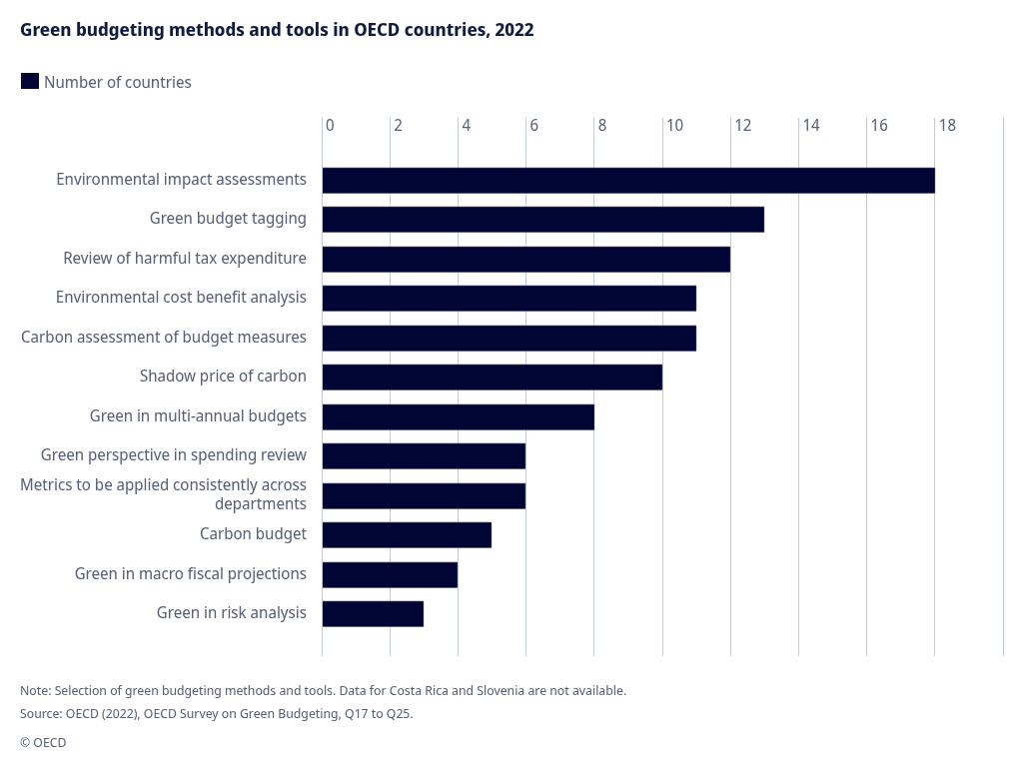

However, in many cases, public budgets do have some of these data points in an unstructured or semi-structured format. However extracting this available information in a comprehensive manner has not been done yet.

3. Proposed use of AI
Within the Hazard-Exposure-Vulnerability (HEV) risk assessment model AI can be applied to extract geolocation data (to evaluate exposure) and asset type information (to evaluate vulnerability) out of public (scope: Austrian municipalities) budget data in a structured manner.
Because this involves processing thousands of financial line items, human validation must be integrated through a workflow that balances data quality with operational feasibility.

4. Scope
Define what is included in the use case and set its boundaries.
Include:
- The process, service or product covered
- The main users or stakeholder groups
- The data, documents or information involved
- The organisational, thematic or geographical coverage
- Anything specifically outside the scope
Maximum: 1 short paragraph or 4 bullets.

5. Expected outcome
Describe the concrete result that the use case is expected to deliver.
Focus on the change or benefit, not the technical output alone.
Consider:
- What will be better, faster, easier or newly possible?
- What will users be able to do differently?
- How will environmental knowledge, services or decisions improve?
- What would demonstrate that the use case is successful?
Maximum: 2 to 3 sentences.

6. Contribution to the environment and digital agenda
Explain how the use case supports both environmental objectives and digital development.
Environmental contribution
Consider whether the use case:
- Improves environmental monitoring, reporting or assessment
- Strengthens the evidence base for policy and implementation
- Improves access to environmental knowledge
- Supports climate, biodiversity, circular economy, pollution or other environmental objectives
- Helps understand or reduce the environmental footprint of digitalisation

Digital contribution
Consider whether the use case:
- Improves digital services
- Strengthens data quality, interoperability or accessibility
- Enables responsible automation
- Builds AI and digital capabilities
- Supports secure, reusable and scalable solutions
- Improves collaboration or knowledge sharing
- Contributes to responsible and trustworthy AI
Maximum: 3 to 4 sentences.

7. Key conditions and considerations
Identify the most important requirements, dependencies or risks.
Consider:
- Availability and quality of data
- Data ownership and access
- Privacy, security or confidentiality
- Responsible AI and regulatory compliance
- Transparency and explainability
- Human oversight
- Required skills and organisational capacity
- Technical infrastructure and integration
- Environmental footprint
- Possibility for reuse or scaling

Example of the intended level of detail
AI-assisted quality control of environmental reporting data
Main area:
AI Applications and Value Creation
Challenge or opportunity:
Currently, reporting and data experts spend substantial effort identifying missing values, inconsistencies and unusual patterns in environmental reporting data. This can delay feedback to reporters and reduce the time available for expert analysis.
Proposed use of AI:
The use case would apply AI to identify and prioritise potential anomalies in submitted environmental data. It would support reporting and data experts by directing their attention to records requiring further review, while experts would remain responsible for validating findings and deciding on follow-up.
Scope:
The use case covers initial quality screening of selected environmental reporting dataflows. It uses submitted data, validation rules and relevant historical records. It does not include fully automated acceptance or rejection of reported data.
Expected outcome:
The expected outcome is earlier identification of potential data-quality issues and more focused use of expert capacity. Success would be demonstrated by useful detection of anomalies, faster feedback and reduced repetitive screening.
Contribution to the environment and digital agenda:
The use case contributes to the environmental agenda by improving the reliability and timeliness of information used for environmental monitoring and assessment. It supports the digital agenda by strengthening data quality and introducing responsible automation into reporting services.
Key conditions and considerations:
- Suitable and representative data must be available.
- Results must be transparent enough for expert validation.
- Data ownership and responsibilities must be clear.
- Human review must remain part of the workflow.
- The solution should be designed for possible reuse across dataflows.

